  
**  
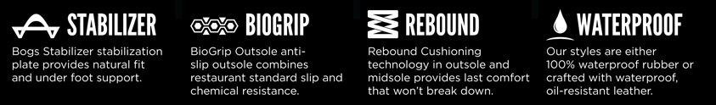  
**Description**

**The Stewart Clog is 100% waterproof, created with seamless injected 100% Rebound rubber construction in one piece for maximum comfort. The Bogs stabilizer provides a natural fit and under foot support. Rebound rubber outsole with DuraFresh bio-technology that fights foot odours. Bio-Grip anti-slip outsole combines restaurant standard slip & chemical resistance.**

**Features**

* + **100% Waterproof**
  + **BioGrip the ultimate in slip resistance on wet, dry or oily surfaces**
  + **Restaurant standard non-slip & chemical resistance**
  + **Rebound rubber for under foot support & comfort**
  + **DuraFresh bio-technology fights foot odours**
  + **100% Rebound rubber**
  + **Suitable for: Hard wet floors, hospitality, kitchen chef, hospital, aged care**

 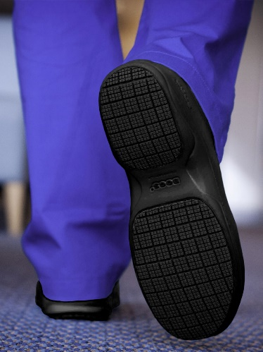 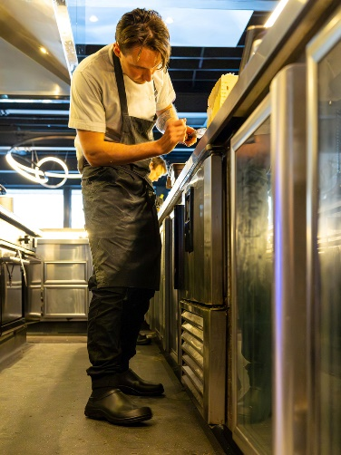 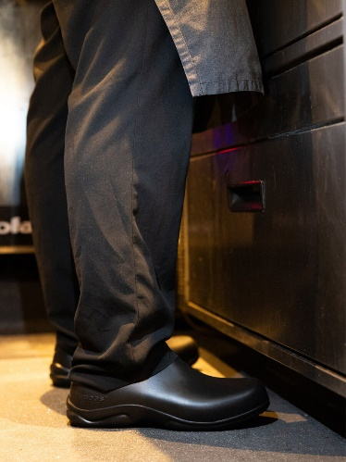

**AVAILABLE IN BLACK ONLY**

**Suitable for: Hard wet floors, hospitality, kitchen, chef, hospital, aged care**

